Tutorial 3 – AR Sensing and Autonomous Tracking

Exercise 3.1 – Creating a launch file to open your webcam
- Install the package usb_node to allow the usage of cameras connected via usb.
$ sudo apt-get install ros-(version name e.g.foxy)-usb-cam

- To find the camera connection to which port and index of the turtlebot, use the command
$ ls –lthrh /dev/video*
- Launch tmux on the turtlebot3
$ tmux
- On your desktop, connect to the turtlebot
$ tmux a -t [tmux terminal]

- Create a launch file, called cam.launch.py within the Turtlebot to launch the package: usb_cam with the type: usb_cam_node_exe
from launch import LaunchDescription
from launch_ros.actions import Node

def generate_launch_description():
return LaunchDescription([
Node(
package="___EDIT HERE____ " ,
executable="____EDIT HERE____",
parameters=[{
"video_device": "/dev/video*" ,
"image_width": 640,
"image_height": 480,
"framerate": 10.0,
"camera_frame_id": "camera_link" ,
"pixel_format": "yuyv",
}],
name="camera"
),
Node(
package="image_view",
executable="image_view"
remappings=[
("image", "camera/image_raw"),
],
output="screen",
emulate_tty=True,
respawn="false",
name="image_view"
),
])

- Launch the demo_launch.py file
$ ros2 launch usb_cam demo_launch.py
- Change the mapping to camera
$ ros2 run tf2_ros static_transform_publisher 0 0 0 0 0 0 map camera

- In another tmux terminal, launch rviz2
$ rviz2
- After launching the newly created launch file, use the command and add new visualization type called: Image. Cascade the Image type visualization and select the Image Topic as /camera/image_raw
There should be a live image from the camera as shown in Figure 1. [UPDATE IMG]

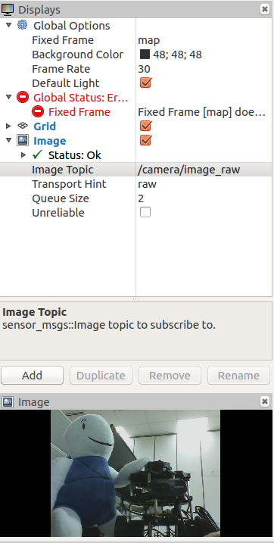
Figure 1. Example of an Image Streamed from Webcam
Exercise 3.2 – Calibrating the Camera
https://navigation.ros.org/tutorials/docs/camera_calibration.html (size 8x6)
- Install Camera Calibration Parser, Camera Info Manager & Launch Testing
sudo apt install ros-foxy-camera-calibration-parsers
sudo apt install ros-foxy-camera-info-manager
sudo apt install ros-foxy-launch-testing-ament-cmake
- Image Pipeline need to be built from source in your workspace with:
git clone -b foxy git@github.com:ros-perception/image_pipeline.git
- Launch the ROS driver for the camera
- Make sure camera is publishing images over ROS by running
ros2 topic list
- Start camera calibration node
ros2 run camera_calibration cameracalibrator --size 8x6 --square 0.20 image:=/my_camera/image_raw camera:=/my_camera
- Once the calibration is complete, click Save and Commit. Locate the generated file and do the following to make it accessible by the workspace.
$ tar -xvf calibration.tar.gz
- Rename the ost.txt file into a new filename.ini and run the following command before placing it into a desired ROS package path.
$ rosrun camera_calibration_parsers convert filename.ini newfilename.yaml
- Insert a new line of parameter (for your camera node) within the launch file created in Exercise 3.1
<param name="camera_info_url" value="file://$(find rospackage) /newfilename.yaml" />

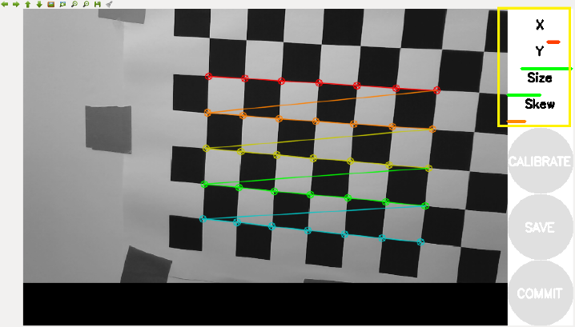
Figure 2. Calibration process with 4 bars marked in yellow box.

Exercise 3.3 - Detecting a AR Tag with OpenCV
- Create a package named cv_basics with dependencies on rclpy, image_transport, cv_bridge, sensor_msgs, std_msgd and opencv2
- Move to the cv_basics packages
cd ~/workspace_name/src/cv_basics/cv_basics
- Open a new Python file named camera.py
[insert code from TB]

- Modify the setup.py file to add the new script.
entry_points={
'console_scripts': [
'img_publisher = cv_basics.camera:main',
],
},

- Modify the package.xml file to edit the openCV dependency to python3-opencv.
<depend>python3-opencv</depend>

- Return to the root of the workspace and ensure all dependencies are installed, before building the package.
rosdep install -i --from-path src --rosdistro foxy -y
- Run the node - img_publisher
ros2 run cv_basics img_publisher

Exercise 3.4 – Creating a Turtlebot AR Tracker
The following task would allow the Turtlebot to track an AR tag. Breakdown of task:
- Obtain the right orientation and direction between the Turtlebot and the AR tag.

- The Turtlebot needs to publish forward and backward velocity based on the distance to the AR tag. (i.e. go forward if too far, backwards if too near).

- The Turtlebot has to orientate itself to the AR tag so it will stay perpendicular to the it.

Task 1: It can be observed using rviz as done in Exercise 3.3. Look for the axis which the AR tag shifts as it moves forward/backward (for Task 2). Look for the axis which the AR tag shifts as it moves sideways (for Task 3). The coordinate system in rviz is in the order of RGB.

Task 2: Using the concept of a proportional controller, it will (1) reduce/increase the speed of the Turtlebot as well as (2) going forward/backward based on its distance to the AR tag. The of the proportional controller will be the linear velocity needed to publish to the Turtlebot.
The Equation of a Proportional Controller is as given:
Where:
- is an arbitrary constant decided by the user.
- is the current distance between Turtlebot and the AR tag.
- is the fixed distance between the Turtlebot and the AR tag which the Turtlebot is required to stop.

Task 3: Use the Pythagoras’ Theorem to determine the angle to which the AR tag is location at. After the angle is found, use a similar Proportional Controller in Task 2 (without ) to publish the angular velocity.
Pythagoras’ Theorem
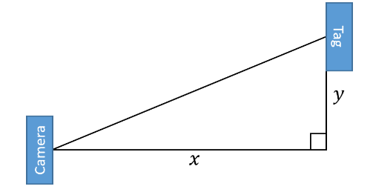
The main structure of the tracker has been provided below:
#!/usr/bin/env python3
import rclpy
from rclpy.node import Node
from std_msgs.msg import String
import math # Required for using math function
import geometry_msgs.msg
from ros2_aruco_interfaces.msg import ArucoMarkers

class ArTracker(Node):

def __init__(self):
super().__init__('ar_tracker')
####### Declaring Class attributes Variables ##########

EDIT HERE

############################################

# Subscription to AR pose detector
####### Create a ROS2 subscriber to the Aruco markers ##########

EDIT HERE

############################################

# Publisher to command velocity
####### Create a ROS2 publisher to move the robot every 0.1 seconds ##########

EDIT HERE

############################################

# Function to compute velocity to chase the AR tag
####### Create a ROS2 publisher to compute velocity based on the distance and ##########
####### orientation to the aruco marker every 0.1 seconds ##########

EDIT HERE

############################################

def check_if_visible_callback(self, data):
####### Callback function to the aruco marker subscriber object ##########

EDIT HERE

############################################

def cmd_vel_timer_callback(self):
####### Callback function for the publisher to command velocity ##########

EDIT HERE

############################################

def chase_tag(self):
angular = *math.atan2(trans[y],trans[x])
linear = *( trans[x] - 0.5)

####### Velocity computation function ##########

EDIT HERE

############################################

def main(args=None):
rclpy.init(args=args)
print("AR Tracking!")

ar_tracker = ArTracker()

rclpy.spin(ar_tracker)

# Destroy the node explicitly
# (optional - otherwise it will be done automatically
# when the garbage collector destroys the node object)
ar_tracker.destroy_node()
rclpy.shutdown()

if __name__ == '__main__':
main()

Additional Task: Add a True/False function to stop the Turtlebot when no AR Tags were found.

Executing the script:
For Exercise 3.4, the following files will need to be launched in sequence to allow the navigation of the Turtlebot.
From Turtlebot:
For publish velocity:
$ ros2 launch turtlebot3_bringup robot.launch.py
For camera:
$ ros2 launch your_pkg cam.launch.py
If AR tracker has been installed within the Turtlebot:
$ ros2 run ros2_aruco aruco_node
Else, execute from the Host PC.

From Host PC:
The AR tracker python script:
$ ./your_script_from_exercise_3.4.py

Red = x-axis, Green = y-axis, Blue = z-axis

